Why do I receive 2 responses for each HTTP request coming in to nodemon.

Example:

Using Chrome web browser was used to generate Get request (Get the info in the database for a certain id.)

<http://localhost:5000/3>

was sent,

The console shows that, as a result of the single request, two request messages were sent to the back end server.

The first request (receiving a status code of 200) is called a CORS preflight message in which the backend software checks that all is well with the request so the message is s.

The second request (receiving a status code of 30) sends back the complete response (data including the data from the SQL Server)

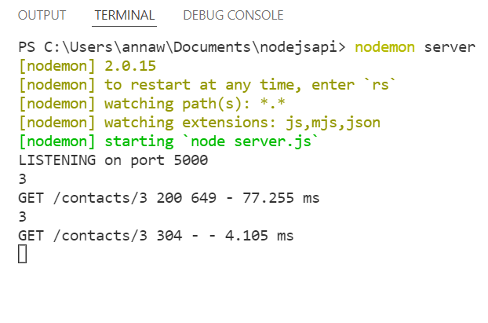

The data received by the Chrome Browser is as follows

:

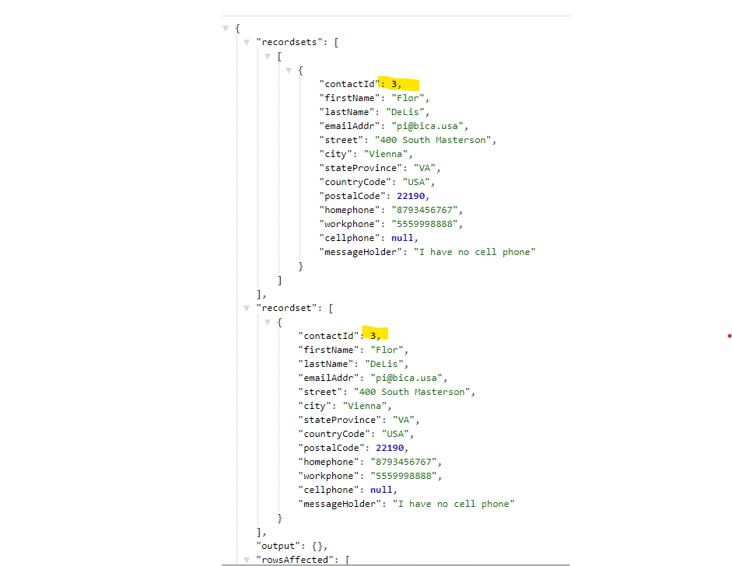

CORS: the Cross Origin Resource S..? will allow access to clients from different systems. Consequently, the first response sent to the browser should be a code 200: “I have checked your ‘header’ and everything is appropriate. I will now process the HTTP data, at which time the HTTP response will then now transmit the data in the second reply with the data that you requested.

Example:

